DECLARATION  I declared that the details furnished are true to the best of my knowledge. I agree to abide by the rules and regulations governing the training programme. In any case if I am unable to attend the training programme, I am prepared to forego the advance paid by me.  Place:  Date: Signature of theParticipant  SPONSORSHIP CERTIFICATE  Mr/Ms/Dr.….……………………………....………..is an employee/ a student of our institute and hereby sponsored. He/She will be permitted to attend the course.  Signature of theSponsoring Authority withSeal  ADDRESS FOR COMMUNICATION  Mr.R.Soundararaj,  Asst.Prof/Mech  Phone No:9629418434  Email Address:soundararajmechanical@mailamengg.com | CHIEF PATRONS  Shri.M.DHANASEKARAN  Chairman and Managing Director,  Mailam Subramaniya Swamy Educational Trust  Dr. K. NARAYANASAMY  Secretary,  Mailam Subramaniya Swamy Educational Trust  Shri.D.RAJARAJAN  Treasurer,  Mailam Subramaniya Swamy Educational Trust  PATRONS  Dr. S. SENTHIL  Director  Dr.R.RAJAPPAN  Principal  CONVENOR  Dr.S.VANDAARKUZHALI  HoD/Mech  CO-ORDINATOR  Mr.K.SUNDARA VINAYAGAM  Asso.Professor/Mech  IMPORTANT DATE  Last Date for Registration 13.09.2025  Registration Link:  https://forms.gle/mFEV8y4xvnYv2qKj8 |   (Approved by AICTE, New Delhi, Affiliated to Anna University Chennai  & Accredited by NBA and TCS, NAAC with “A” Grade)  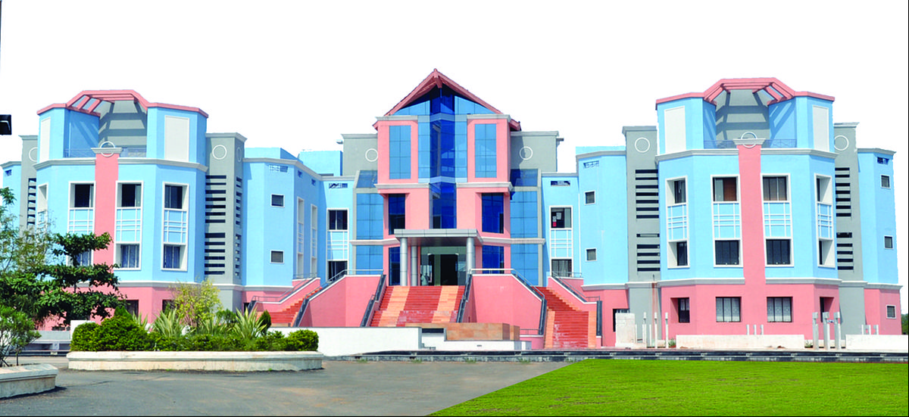  ONE WEEK ONLINE  FACULTY DEVELOPMENT PROGRAMME  on  CE3391-FLUID MECHANICS AND MACHINERY  18th Sep – 24th Oct 2025  Organized by  Department of Mechanical Engineering  Mailam Engineering College,  Mailam – 604304  Tindivanam Taluk,  Phone:04147-241515/241551  Fax:04147-241552  Website: https://mailamengg.com/
ABOUT THE INSTITUTION  Mailam Engineering College is a self-financed educational institution runs by Mailam Subramaniya Swamy Educational Trust since 1998. The college is approved by AICTE,affiliated to Anna University and accreditedby NBA. The college is accredited to by the IT giant, TATA Consultancy Services, which is recruiting our students in large numbers every year.  In addition to providing a tranquil and pleasant atmosphere for the pursuit of technical education with separate block for all departments, the college bounds with highly qualified, experienced and competent faculty members with a zeal of excellence and commitment for uncompromising quality education. With more than 3500 students passionately pursuing their professional course in the college, MEC enjoys the privilege of having the largest intake of students on first year B.E/ B.Tech approved by Anna University in the District ofVillupuram.  ABOUT THE MECHANICAL DEPARTMENT  The Department of Mechanical Engineering was started in the year of 1998 and offers UG (Mechanical Engineering) and PG (Engineering Design). The department has highly qualified, dedicated and efficient teaching and non-teaching staff members. Laboratories such as Manufacturing Technology Lab, Fluids Mechanics and Machinery Lab, Strength of Material Lab, Thermal Lab, Metrology and Measurement Lab, Dynamic Lab, CAD/CAM Lab, Mechatronics Lab and Analysis and Simulation Lab are well equipped and designed in such a way to provide and industrial environment to the students. The main objective of the department is to develop a centre of excellence in the broad area of Mechanical Engineering, so as to provide a world class education to students and to promote innovative research and developments. | COURSE CONTENTS  The FDP covers the following areas of  - Fluid Properties And Flow Characteristics  - Flow Through Pipes And Boundary Layer  - Dimensional Analysis And Model Studies  - Turbines  - Pumps  RESOURCE PERSONS  Sessions will be handled by the Experienced faculty members from premier institutions / Industrial experts will deliver the lectures and handle the practical sessions.  HOW TO REACH  The college is situated at Mailam on Tindivanam to Puducherry State Highway (SH 136). It is about 15kms from Tindivanam. It is well connected by rail and road.  REGISTRATION  Application either the attached form or a google form should be forwarded to the Coordinator through post/courier/online on or before 27th April 2025. Selectedcandidates will be intimated through email only.  ELIGIBILITY  Students from AICTE recognized Engineeringcolleges, Practicing Engineers from private andgovernment organizations, scientists / Engineers fromR&D establishments are eligible to apply. | ONE WEEK ONLINE  FACULTY DEVELOPMENT PROGRAMME  on  CE3391-FLUID MECHANICS AND MACHINERY  18th Sep – 24th Oct 2025  REGISTRATION FORM  Name:Dr./Mr./Ms:--------------------------------------  Gender:---------------------------------------------------  Designation/Dept.:---------------------------------------  Institution:------------------------------------------------  Academic Qualifications:------------------------------  Mobile No. :---------------------------------------------  E-mail:-----------------------------------------------------  Address: --------------------------------------------------  --------------------------------------------------------------  --------------------------------------------------------------  PIN Code: -------------------------------------------------  Date:  Signature of the Applicant

